**DESIGN OF ELECTROCARDIOGRAPHY FOR MONITORING**

**Objective :**

The objective of this project is to create a device that is capable of monitoring Electrocardiogram (ECG) of a patient in ambulatory situations. From these signals, several data can be extracted in order to avoid dangerous situations or detect cardiological pathologies.The final product has to be small and portable so that it can be effortlessly interfaced with the user. For this reason the connection is simplified to only 3 electrodes. The device communicates with a smartphone over the net. Hence, waveform can be viewed easily.

**High Level Design / Background:**

ECG Devices have been used in medical settings for many years. In many cases, such as during an operation, in intensive care, the emergency room, even an ambulance van, a person’s Electrocardiogram may be unstable and needs monitoring. In addition, from these readings, the person’s current health status may be determined. This project is an attempt to construct a working version of a ECG device from a relatively cheap set of parts – including a Microcontroller and a WiFi module. An off-the-shelf Microcontroller has enough processing power to perform the tasks required for this design.

For this project a three lead sensor module called **ADS1292R** is used.

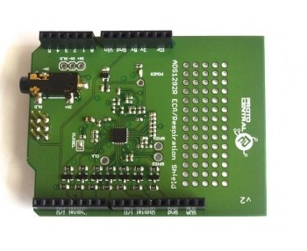

**NodeMCU:**

NodeMCU is a lua based Microcontroller which contains a WiFi module using which we communicate the results over the Internet. This module is interfaced with the ADS1292R which is mounted on top of the Arduino UNO board.The Pin diagram for the controller is as follows :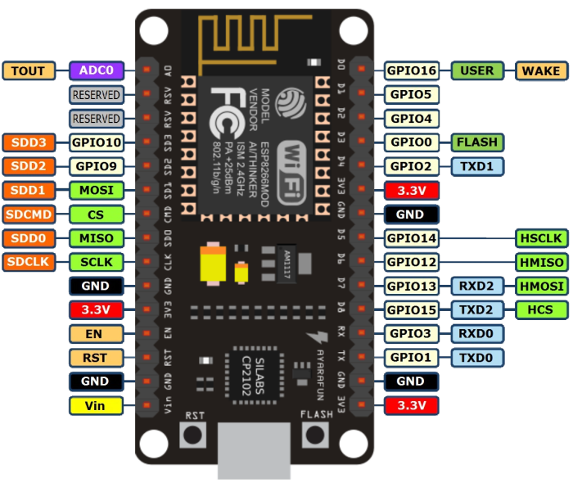

**Arduino UNO:**

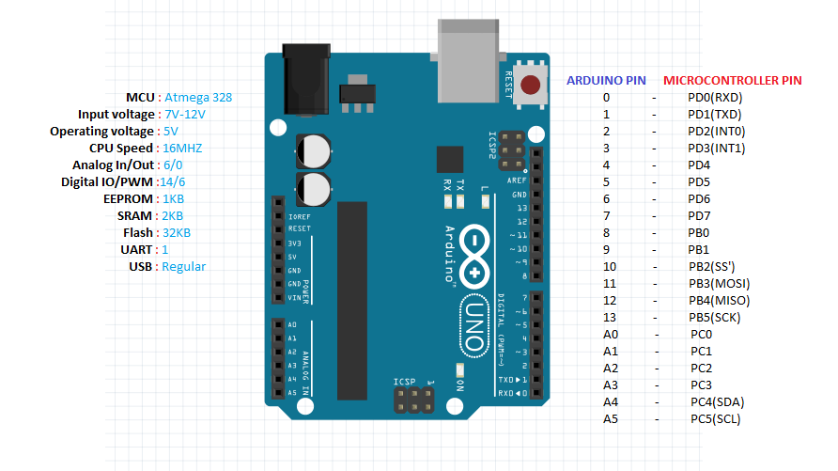

The final assembled product looks like follows:

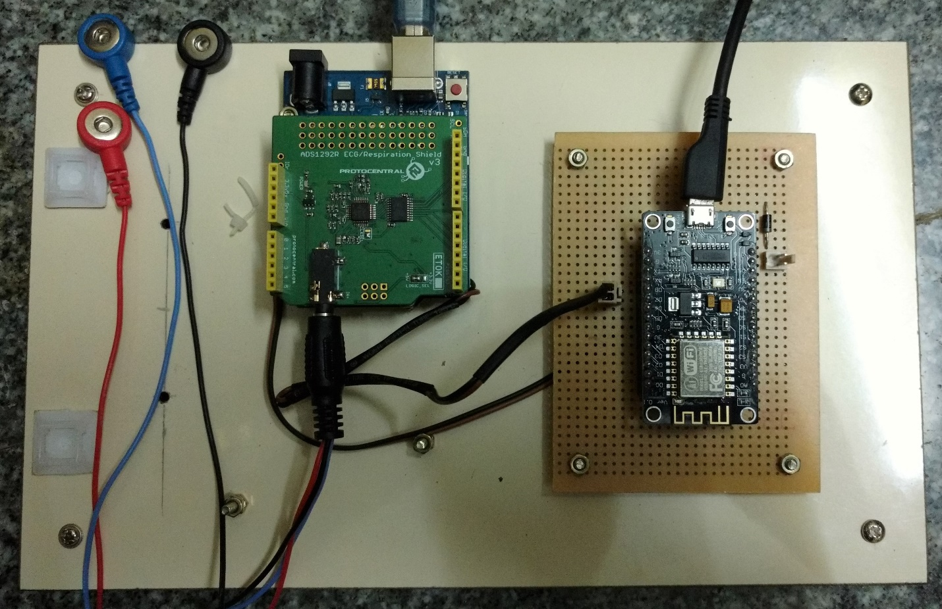

**Program:**

**#include <ads1292r.h>**

**#include <SPI.h>**

**uint8_t DataPacketHeader[16];**

**ads1292r ADS1292;**

**//Packet format**

**#define CES_CMDIF_PKT_START_1 0x0A**

**#define CES_CMDIF_PKT_START_2 0xFA**

**#define CES_CMDIF_TYPE_DATA 0x02**

**#define CES_CMDIF_PKT_STOP 0x0B**

**uint8_t data_len = 8;**

**unsigned long time;**

**volatile byte SPI_RX_Buff[15] ;**

**volatile static int SPI_RX_Buff_Count = 0;**

**volatile char *SPI_RX_Buff_Ptr;**

**volatile int Responsebyte = false;**

**volatile unsigned int pckt = 0 , buff = 0, t = 0 , j1 = 0, j2 = 0;**

**volatile unsigned long int RESP_Ch1_Data[150], ECG_Ch2_Data[150];**

**volatile unsigned char datac[150];**

**unsigned long uecgtemp = 0, Pkt_Counter = 0;**

**signed long secgtemp = 0;**

**volatile int i;**

**volatile long packet_counter = 0;**

**void setup()**

**{**

**// initalize the data ready and chip select pins:**

**pinMode(ADS1292_DRDY_PIN, INPUT); //6**

**pinMode(ADS1292_CS_PIN, OUTPUT); //7**

**pinMode(ADS1292_START_PIN, OUTPUT); //5**

**pinMode(ADS1292_PWDN_PIN, OUTPUT); //4**

**//initalize ADS1292 slave**

**ADS1292.ads1292_Init();**

**//ADS1292.ads1292_Reset();**

**}**

**void loop()**

**{**

**if ((digitalRead(ADS1292_DRDY_PIN)) == LOW)**

**{**

**SPI_RX_Buff_Ptr = ADS1292.ads1292_Read_Data();**

**Responsebyte = true;**

**//Serial.print("DRDY low: ");**

**}**

**if (Responsebyte == true)**

**{**

**/*Serial.print("start Time: ");**

**time = millis();**

**//prints time since program started**

**Serial.println(time);**

**\*/**

**for (i = 0; i < 9; i++)**

**{**

**SPI_RX_Buff[SPI_RX_Buff_Count++] = *(SPI_RX_Buff_Ptr + i);**

**}**

**Responsebyte = false;**

**}**

**if (SPI_RX_Buff_Count >= 9)**

**{**

**pckt = 0; j1 = 0; j2 = 0;**

**for (i = 3; i < 9; i += 9)**

**{**

**//udi_cdc_putc(SPI_RX_Buff[i]);**

**//RESP_Ch1_Data[j1++]= SPI_RX_Buff[i+0];**

**//RESP_Ch1_Data[j1++]= SPI_RX_Buff[i+1];**

**//RESP_Ch1_Data[j1++]= SPI_RX_Buff[i+2];**

**ECG_Ch2_Data[j2++] = (unsigned char)SPI_RX_Buff[i + 3];**

**ECG_Ch2_Data[j2++] = (unsigned char)SPI_RX_Buff[i + 4];**

**ECG_Ch2_Data[j2++] = (unsigned char)SPI_RX_Buff[i + 5];**

**RESP_Ch1_Data[j1++] = (unsigned char)SPI_RX_Buff[i + 0];**

**RESP_Ch1_Data[j1++] = (unsigned char)SPI_RX_Buff[i + 1];**

**RESP_Ch1_Data[j1++] = (unsigned char)SPI_RX_Buff[i + 2];**

**}**

**packet_counter++;**

**uecgtemp = (unsigned long) ((ECG_Ch2_Data[0] << 16) | (ECG_Ch2_Data[1] << 8) | ECG_Ch2_Data[2]);**

**uecgtemp = (unsigned long) (uecgtemp << 8);**

**secgtemp = (signed long) (uecgtemp);**

**secgtemp = (signed long) (secgtemp >> 8);**

**//Serial.println(secgtemp);**

**DataPacketHeader[0] = 0x0A;**

**DataPacketHeader[1] = 0xFA;**

**DataPacketHeader[2] = (uint8_t) (data_len);**

**DataPacketHeader[3] = (uint8_t) (data_len >> 8);**

**DataPacketHeader[4] = 0x02;**

**DataPacketHeader[5] = secgtemp;**

**DataPacketHeader[6] = secgtemp >> 8;**

**DataPacketHeader[7] = secgtemp >> 16;**

**DataPacketHeader[8] = secgtemp >> 24;**

**uecgtemp = (unsigned long) ((RESP_Ch1_Data[0] << 16) | (RESP_Ch1_Data[1] << 8) | RESP_Ch1_Data[2]);**

**uecgtemp = (unsigned long) (uecgtemp << 8);**

**secgtemp = (signed long) (uecgtemp);**

**secgtemp = (signed long) (secgtemp >> 8);**

**DataPacketHeader[9] = secgtemp;**

**DataPacketHeader[10] = secgtemp >> 8;**

**DataPacketHeader[11] = secgtemp >> 16;**

**DataPacketHeader[12] = secgtemp >> 24;**

**DataPacketHeader[13] = 0x00;**

**DataPacketHeader[14] = 0x0b;**

**// for (i = 0; i < 15; i++) // transmit the data**

**// {**

**Serial.write(DataPacketHeader[i]);**

**// }**

**}**

**SPI_RX_Buff_Count = 0;**

**delay(7.5);**

**}**

**Waveform :**

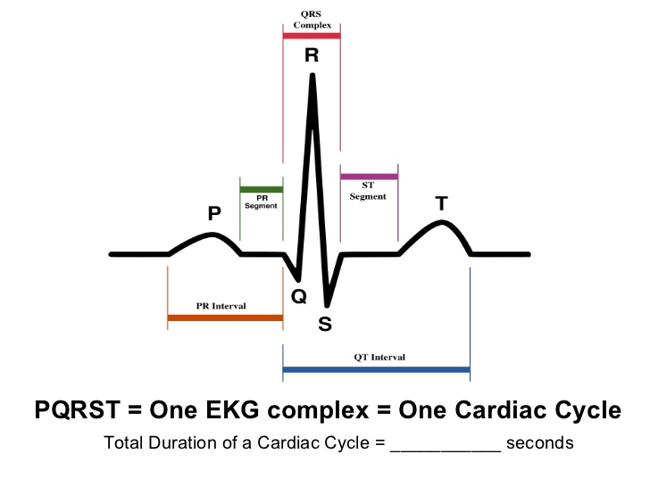

**Noise Processing :**

Electrocardiogram traces used for identification are obtained using surface electromyography (EMG), where electrodes are placed on the skin in the vicinity of the heart. Potential differences of 1 to 3 mV generated at the body surface by the current sources in the heart are picked up by the electrodes and are amplified in order to improve the signal to noise ratio (SNR). The ECG waveform is observed on an oscilloscope or Computer or

is digitized for further processing by a hardware device (as will be the case for recognition purposes). The digitization process should use a sampling rate of at least 1 kHz to ensure that the ECG trace is of a high enough resolution as required for biometric purposes [1].

ECG measurements may be corrupted by many sorts of noise. The ones of primary interest are:

1. Power line interference,
2. Electrode contact noise,
3. Motion artifacts,
4. EMG noise, and
5. Instrumentation noise.

The various noise signals presented in the figure will be characterized in greater detail in this section.

## Power Line Interference

Plotting a Fourier power spectrum of a typical ECG signal reveals various common ECG frequency components. Several interesting features are readily identifiable:

* The 1.2 Hz heart beat information (approximately 72 beats per minute)
* The 60 Hz power line interference

The remainder of the frequency components represents the subject information (situated between 0.1 Hz and 40 Hz) and contributions of other noise sources.

Power line interference occurs through two mechanisms: capcaitive and inductive coupling. Capacitive coupling referes to the transfer of energy between two circutis by means of a coupling capacitance present between the two ciricuits. The value of the coupling capacitance decreases with increasing separtion of the circuits. Inductive coupling on the other hand is caused by mutual inducatance between two conductors. When current flows through wires it produces a magnetic flux, which can induce a current in adjacent cirucits. The geometry of the conductors as well as the separtion between them determines the value of the mutual inductance, and hence the

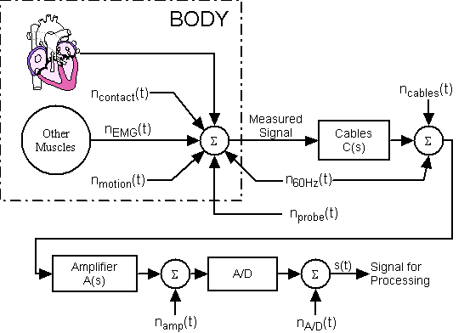

degree of the inductive coupling. Typically, capacitive coupling is responsible for high frequency noise while inductive coupling introduces low frequency noise. For this reason inductive coupling is the dominant mechanism of power line interference in electrocardiology. Ensuring the electrodes are applied properly, that there are no loose wires, and that all components have adequate shielding should help limit the amount of power line intererence.

The manifestation of power line noise can be modeled by

. (1)

The average peak value, *A*, of the noise depends on the amount of coupling between the ECG equipment and the power lines, and will vary between measurements. During measurement the peak-to-peak value is also liable to fluctuate due to changing environmental conditions, which influence the amount of inductive or capacitive coupling of power lines to the ECG equipment. The phase of the sinusoid, represented by  in equation (1), is a random variable with a uniform distribution in the range [-π, π). This simplistic model assumes that the noise will occur only at 60 Hz, but in reality the power line noise will have a finite bandwidth around its nominal center frequency, suggesting that the total noise is composed of many sinusoids of similar frequency.

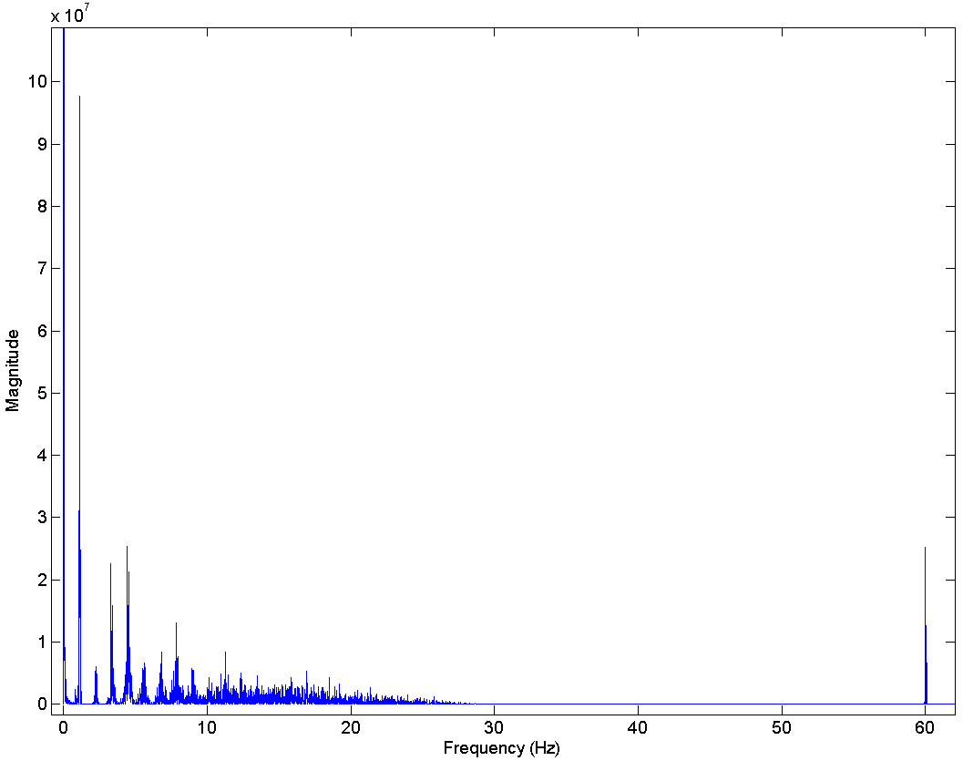

Fourier power spectrum of an ECG trace. The 60 Hz power line interference and the baseline potential drift noise (at approximately 0 Hz) are identifiable.

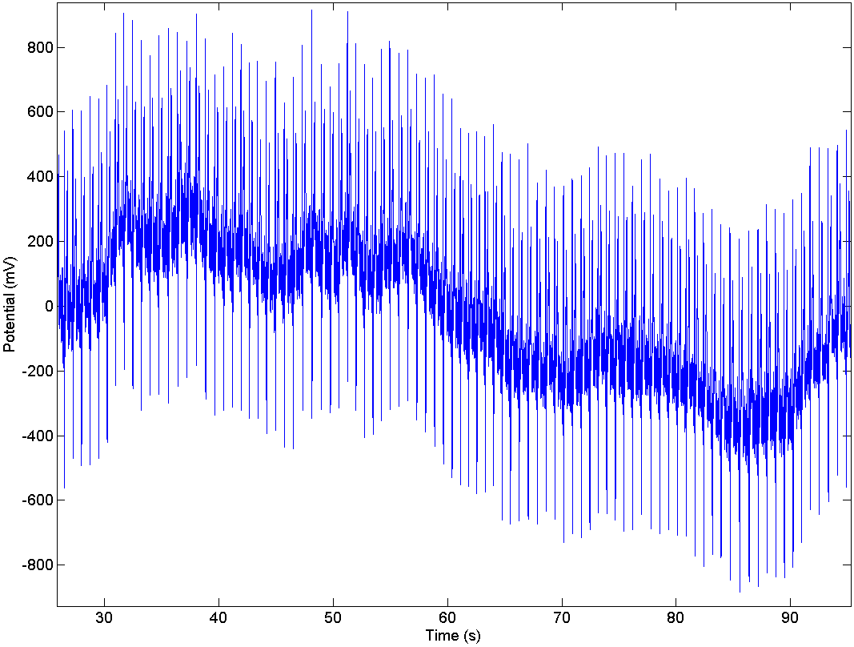

Seventy seconds of ECG data. The *x*-axis is time in seconds, and *y*-axis is the electrical potential in millivolts. A baseline potential drift is present in the ECG trace.

## Electrode Contact Noise and Motion Artifacts

Electrode contact noise is caused by variations in the position of the heart with respect to the electrodes and changes in the propagation medium between the heart and the electrodes. This causes sudden changes in the amplitude of the ECG signal, as well as low frequency baseline shifts. In addition, poor conductivity between the electrodes and the skin both reduces the amplitude of the ECG signal and increases the probability of disturbances (by reducing SNR). The underlying mechanism resulting in these baseline disturbances is electrode-skin impedance variation. The larger the electrode-skin impedance, the smaller the relative impedance change needed to cause a major shift in the baseline of the ECG signal. If the skin impedance is extraordinarily high, it may be impossible to detect the signal features reliably in the presence of body movement [4]. Sudden changes in the skin-electrode impedance induce sharp baseline transients which decay exponentially to the baseline value. This transition may occur only once or rapidly several times in succession. Characteristics of this noise signal include the amplitude of the initial transition and the time constant of the decay. The contact noise is represented by *n*contact(*t*) .

Motion artifacts are transient (but not step) baseline changes caused by electrode motion. The usual causes of motion artifacts are vibrations, movement, or respiration of the subject. The peak amplitude and duration of the artifact are random variables which depend on the variety of unknowns such as the electrode properties, electrolyte properties (if one is used between the electrode and skin), skin impedance, and the movement of the patient. Fig. 4 shows a 70 second segment of a high resolution ECG trace, where the baseline drift varies from approximately -400mV to 400mV. In this ECG signal, the baseline drift occurs at an unusually low frequency (approximately 0.014Hz), and most likely results from very slow changes in the skin-electrode impedance. This noise can also be observed on the Fourier power spectrum in Fig. 3; the large peak nearest to DC is the result of very low frequency base line shifts. The noise artifacts introduced by subject motion are modeled by *n*motion(*t*).

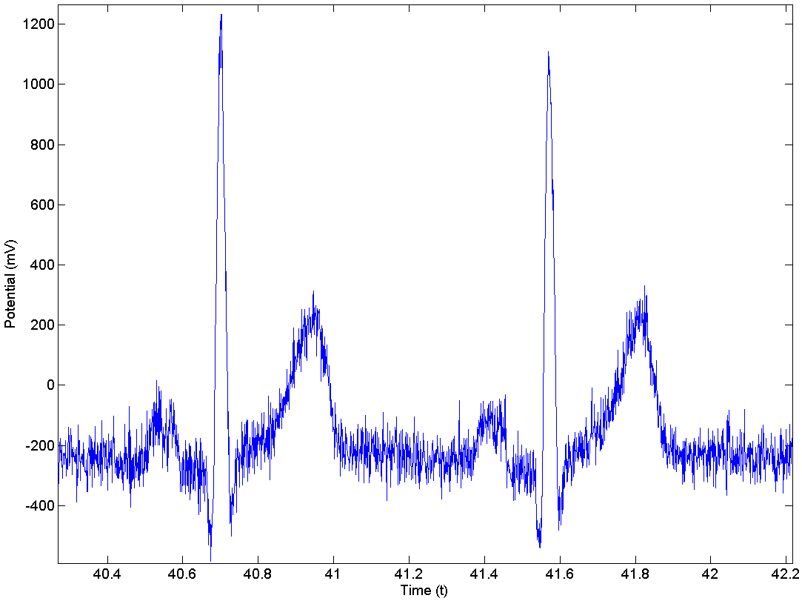

## EMG Noise

EMG noise is caused by the contraction of other muscles besides the heart. When other muscles in the vicinity of the electrodes contract, they generate depolarization and repolarization waves that can also be picked up by the ECG. The extent of the crosstalk depends on the amount of muscular contraction (subject movement), and the quality of the probes.

It is well established that the amplitude of the EMG signal is stochastic (random) in nature and can be reasonably modeled by a Gaussian distribution function [5]. The mean of the noise can be assumed to be zero; however, the variance is dependent on the environmental variables and will change depending on the conditions. Certain studies have shown that the standard deviation of the noise is typically 10% of the peak-to-peak ECG amplitude [3]. While the actual statistical model is unknown, it should be noted that the electrical activity of muscles during periods of contraction can generate surface potentials comparable to those from the heart, and could completely drown out the desired signal. The effects of typical EMG noise can be observed in the ECG signal shown in Fig. 5, and is particularly problematic in the areas of the P and T complexes. This noise is modeled by *n*EMG(*t*).

Instrumentation Noise

The electrical equipment used in ECG measurements also contributes noise. The major sources of this form of noise are the electrode probes, cables, signal processor/amplifier, and the Analog-to-Digital converter, represented respectively by *n*probe(*t*), *n*cables(*t*), *n*amp(*t*), and *n*A/D(*t*). Since this form of noise is usually defined by a white Gaussian distribution, Fig. 5 adequately represents its effects on the ECG signal. Unfortunately instrumentation noise cannot be eliminated as it is inherent in electronic components, but it can be reduced through higher quality equipment and careful circuit design.

One type of electrical noise is resistor thermal noise (also known as Johnson noise). This noise is produced by the random fluctuations of the electrons due to thermal agitation. The power spectrum of this noise is given by

, (2)

where *k* is the Boltzmann’s constant, *T* is the temperature, and *R* is the resistance [6]. This equation suggests that the resistor thermal noise is white for all frequencies; however, at frequencies larger than 100 THz the power spectrum starts to drop off. For our purposes we can assume the resistor thermal noise to be band limited white noise. This type of noise is generated in the electrodes, in the wire leads connecting electrodes to the amplifier, and in all the resistive electronic components internal to the ECG instrumentation. Since the magnitude of this noise component is substantial relative to the measured signal, its effects are most noticeable in the electrodes and any other electronic equipment prior to the amplifier.

Another form of noise, called flicker noise, is very important in ECG measurements, due to the low frequency content of ECG data. The actual mechanism that causes this type of noise is not yet understood, but one widely accepted theory is that it is caused by the energy traps which occur between the interfaces of two materials. It is believed that the charge carriers get randomly trapped/released and cause flicker noise. For MOSFET devices, the power spectral density of flicker noise is given by,

, (3)

where *k* is the Boltzmann’s constant, *T* is the temperature, *Cox* is the silicon oxide capacitance, *WL* is the transistor area, and *f* is the frequency [6]. As the equation suggests, flicker noise is inversely proportional to frequency, indicating that it becomes dominant at lower frequencies. It can be found in any electronic equipment which utilizes bipolar or metal oxide transistors, such as the amplifier used for signal amplification (or more specifically any device which has material junctions). Flicker noise contributions would be most noticeable at the electrodes since the amplitude of the detected signal is on the order of millivolts.

# DISCUSSION

Limiting the effect of the discussed noise sources is the best way to ensure accurate signal processing, however this is not always possible, so adequate filtering techniques need to be utilized. The characterization of the noise sources should provides a basis for proper filter design. Many studies have already been performed to evaluate the effectiveness of various filtering techniques for ECG signals (such as bandpass, Weiner, Kalman, adaptive, and moving average filtering, to name just a few) [7], [8]. The choice of filter will greatly influence the performance of the processing algorithms and as such it should be chosen very carefully.

When designing the filters it is very important that the design is based on the characteristics of the particular noise. This is crucial to ensure that no subject-relevant data is filtered with the noise. At times this is very difficult since the noise and signal fall in the same frequency range, such as the case of EMG noise. The filtering problem is further complicated if the subject has a health disorder which causes certain features of the signal to be overwhelmed by noise. In this case, using a filter could remove the signal feature entirely, reducing the reliability of the extraction software.

**Conclusion :**

The project has been productive and fruitful to a large extent. Many problems and shortcomings were encountered during the process. Most of them include noises distorting ECG waveform. The noises alter/deform the waveform and change the DC level of the waveform. Most of the noise is due to stray signals and ripple from the DC power supply. This is rectified to a large extent using Digital Signal Processing. It is also observed that the 3-probe sensor is has its limitations in cancelling previously mentioned noises. It can be improved by using sensors with more probes. The only tradeoff with using more probes is the overhead cost associated with the final product.